Arithmetic Reasoning and Analytical thinking

25 minutes

Directions: In each of the following questions, a question stem is followed by 2 different statements. You need to decide whether the statements given are sufficient to answer the question asked. Mark your answer option as
a. If the question can be answered by using any one of the 2 statements alone but not by the other alone.
b. If the question can be answered by using either of the 2 statements alone.
c. If the question can be answered by using the 2 statements together.
d. If the question cannot be answered by using the given statements.
Q1: What is the sum of x and y?
I. The LCM of x and y is 51.
II. One of the 2 numbers is 17.
Q2: In how many days can A and B finish the work if they work on alternate days if A starts the work?
I. A alone can do the work in 30 days.
II. B alone can do the work in 10 days.
Q3: What is the value of x?
I. x^3 = 8
II. x^2 = 4
Q4: P,Q,R,S and T are the only members in a family out of which at least 3 are females. If P is the father of R and Q has 2 sons, then who is the Uncle of R?
I. Q is the grandmother of R.
II. T is the aunt of R.
Q5: Which of the two values a^1/a or b^1/b is greater?
I. a and b both are greater than 2.
II. a is less than b.
Directions for questions 6-8: The pie chart shows the % market share by volume of 5 Companies P,Q,R,S and T in the Television market in the year 2011. The total sales volume wise, in the market in the year 2011 is 4,00,000 TV sets.
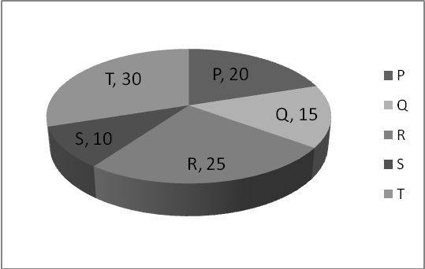
Q6: If S is the others category and company X has a share of 30% in this category, find the number of TV sets sold by company X in the year 2011?
a. 10,000 b. 20,000 c. 12,000 d. 15,000
Q7: If the total sales of 2 products P2 and P3 of company P is 30,000, find the % contribution of products P2 and P3 in the total sales unitwise of company P in the year 2011?
a.37.5% b. 40% c. 60% d. 75%
Q8: By what % is the market share of R more or less than the combined market share of P and S?
a.25% b. 20% c. 16.66% d. none of these

Directions for questions 9-11:

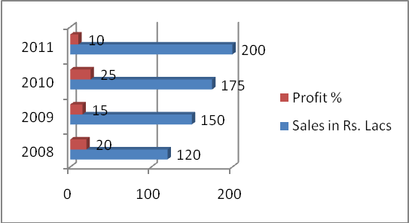

The Bar graph shows the total sales value in Rs. Lacs and the profit% for a company ABC ltd. for 4 years from 2008 to 2011. Answer the questions based on the above data.

Q9: If the total sales is equivalent to the selling price, what is the value of profit for ABC Ltd. for the year 2010?
a. Rs.35 lacs b.Rs.38.75 lacs c. Rs.40 lacs d. None of these
Q10 : Which year has shown the highest % change in profit % ?
a. 2008 b. 2009 c. 2010 d. 2011
Q11 : By what % is the sales in 2011 more or less than the cost in 2008?
a. 50% b. 100% c. 200% d. 250%
Directions for Questions 12 to 15: In each question below, there are two statements followed by two conclusions numbered 1 and 2. You need to decide which of the given conclusions logically follows from the statements given. Mark your answer as
- If only conclusion I follows
- If only conclusion II follows
- If neither I nor II follows
- If both I and II follow
Q12: Statements 1. All A’s are B’s 2. Some B’s are not C’s
Conclusions 1. Some A’s are not C’s 2. Some A’s are C’s is a possibility
Q13: Statements 1. Some P is Q 2. All Q’s are R’s.
Conclusions 1. Some P’s are R’s 2. Some P’s are not R’s.
Q14: Statements 1. Some M’s are N’s 2. Some N’s are O’s.
Conclusions 1. No O is N. 2. Some M is O.
Q15: Statements 1. No A is B 2. No B is C.
Conclusions 1. No A is C 2. C being A is a possibility.

Critical Thinking and Logical Reasoning

35 minutes

Q1: The alphabets that form the word “REASONING” are to be arranged such that no two vowels in the word are together. Find the number of ways in which this can be done?
a. 9!/2! b. 5! x 6P4 c. (5!/2!)x6P4 d. (5!x6!)/2!
Q2: A train travelling at 72 kmph crosses a man moving in the same direction at 5 m/sec in 15 seconds. The train also crosses a bridge in 20 seconds. Find the difference in the length of the train and the length of the bridge?
a. 50 m b. 175 m c. 50 m d. 125 m
Q3: An increase of 5% in the price of wheat leads to a 4 kg decrease in the amount of wheat that can be purchased for Rs.2000. Find the original quantity of wheat being purchased?
a. 80 kg b. 84 kg c. 88 kg d. 78 kg
Q4: A pipe can fill a tank in 8 minutes while a leak can empty the tank in 12 minutes. Initially both are in the open state. After how much time should the leak be plugged so that the tank can get filled in 16 minutes?
a. 8 min b. 12 min c. 10 min d. 9 min
Q5: 24 kg of a flour costing Rs.25 /kg is mixed with 20 kg of another variety such that when the mixture is sold at Rs.60/kg, there is a profit of 20%. Find the cost of the second variety?
a. Rs.75/kg b. Rs.80/kg c. Rs.70/kg d. none of these
Q6: A container is filled with milk. 25% of the contents is drawn out and replaced with an equal quantity of water. This operation is done one more time. Find the ratio of milk to water in the container at the end of the second operation?
a. 9:16 b. 7:9 c. 9:2 d. 9:7
Directions for questions 7-10: Five children visited the fair on five different days of a week starting on Monday and ending on Friday such that exactly one child visited the fair on each day of the week. The children were Rohit, Shalini, Tarun, Upendra and Varun and their surnames were Mishra, Sinha, Gupta, Sharma and Aggarwal not in any order.
Further instructions are as follows:
i. Rohit visited the fair on Wednesday.
ii. Mishra visited after Gupta but before Aggarwal.
iii. Tarun who is not Gupta visited after Varun.
iv. Shalini’s surname is not Aggarwal.
v. Upendra visited the fair on Monday.
vi. Mishra visited the fair on Thursday.
vii. Sinha and Sharma visited on alternate days with Sinha visiting the fair before Sharma.
Q7: Taking all the conditions into consideration, how many solutions are possible?
a. 1 b. 2 c. 3 d. 4
Q8: If Varun’s surname is Gupta, what is the surname of Shalini?
a. Sinha b. Sharma c. Mishra d. cannot be determined.
Q9: Which person visited on Friday?
a. Varun b. Tarun c. Shalini d. cannot be determined.
Q10: If Shalini visits the fair immediately after Rohit, who visited the fair on Tuesday?
a. Varun b. Tarun c. Shalini d. cannot be determined

